Title, This is a Template for Sus-Lab5 Conference Abstract

Author^{a,*}, Author^{b}, Author^{c}
ª Department , Affiliation, Address, Country
^{b} Department, Affiliation, Address, Country
^{c} Department, Affiliation, Address, Country
*Correspondence: E-mail address

Abstract
Abstracts of scientific papers are sometimes poorly written, often lack important information, and occasionally convey a biased picture. This example provides detailed suggestions for writing the background, methods, results, and conclusions sections of a good abstract.

Keywords: Abstract, preparing a manuscript, writing skills, Grammar

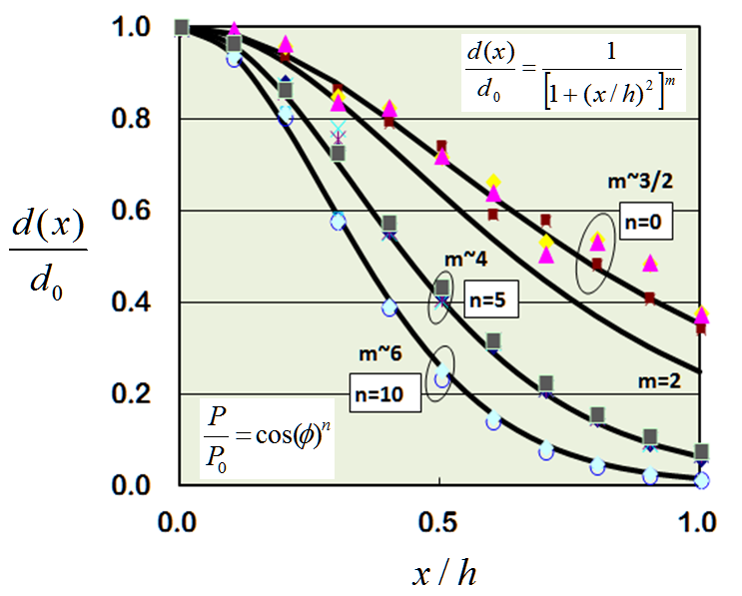
Please place one most significant figure or table in this technical abstract with appropriate caption

